**Emerging Methods For Early Detection Of Forest Fires**

**Abstract**

Natural disasters have always been mankind’s constant companion since time immemorial. Forest fire is one such disaster which when occurs at large scale not only destroys the flora, fauna, vegetation of the forest but also puts the life of human being and animals at a very high risk. In the recent past years, managing this type of crisis, viz., a large scale fire has become a very difficult and challenging task. Things that are common in most of the forest fire that occur at large scale are loss of life (human or animal), loss of vegetation, loss of flora and fauna, and communication failure. Therefore, a comprehensive survey on the existing forest fire detection and monitoring mechanisms is highly desired. This article is aimed at providing a birds eye view of these existing detection and monitoring mechanisms for forest fires.

Keywords Forest fire detection Monitoring Wireless sensor networks

**introduction**

As stated by National Institute of Disaster Management, Ministry of Home Affairs in their latest report on Forest Fire Disaster Management, forest fire is the major cause of injury and loss to forest. This loss due to fire has a major impact on forest ecosystem their by indirectly affecting the nature’s ecosystem. As per one estimate of United Nations Development Program the loss due to such a fire in forest, economically will be around `9000/- per ha per annum (*Reference: [http://nidm. gov.in/pdf/pubs/forest%20fire.pdf](http://nidm.gov.in/pdf/pubs/forest%20fire.pdf)). This means a single event of forest fire at a

1111

large scale will always cause a loss of worth crores which will turn the net asset of forest into ashes. Therefore, greater emphasis is laid on the survey that can be used for the purpose of design and development of detection and monitoring system.

It is because of some activities such as an uncontrolled anthropogenic which makes a fire in the forest to occur at regular intervals. Incidents which lead to regular forest fires include man-made incidents, climate changes, and other factors; there has been a constant increase in the frequency of forest fires. Out of the incidents mentioned above, man-made incidents, i.e., deliberate cause is the most common one. In general fires that occur in the forest can be classified into three types which are:

1. Ground fires,
2. Surface fires, and
3. Crown fires.

Ground fires as given in occur basically on the floor of forest which will produce much heat but without flames. This type of fire is a result of peaty leaves which will be always found on the floor of forest. One more cause can be the organic component of soil which will be formed by the process of decomposition of leaves and other plant materials by soil microorganisms. Ground type of fires is rarest of the three and has been rarely recorded because they normally occur at forests which are situated at very high altitudes such as Himalayan forests. To detect this type of fires, which is a very difficult task, sensors which can record and measure even a temperature difference of as small as 1 °C also should be used.

Therefore, one can go for the implementation of thermal sensors and radiation sensors for this purpose. Authors of article [1] propose the use of animals to be used as biological sensors. The animal which is suited for detection of ground fire are

GROUND FIRE

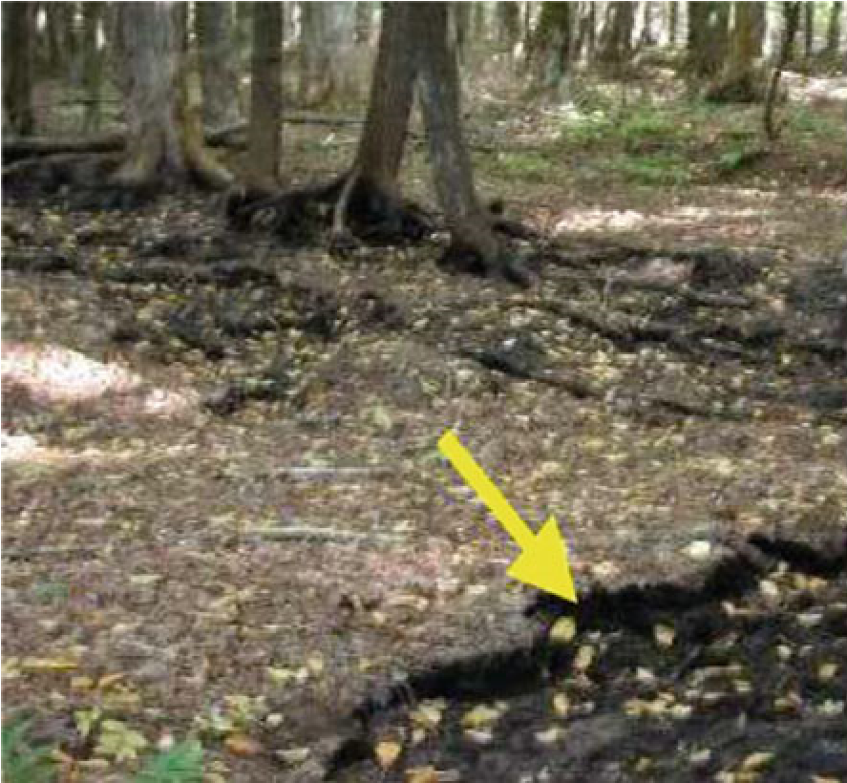

SURFACE FIRE

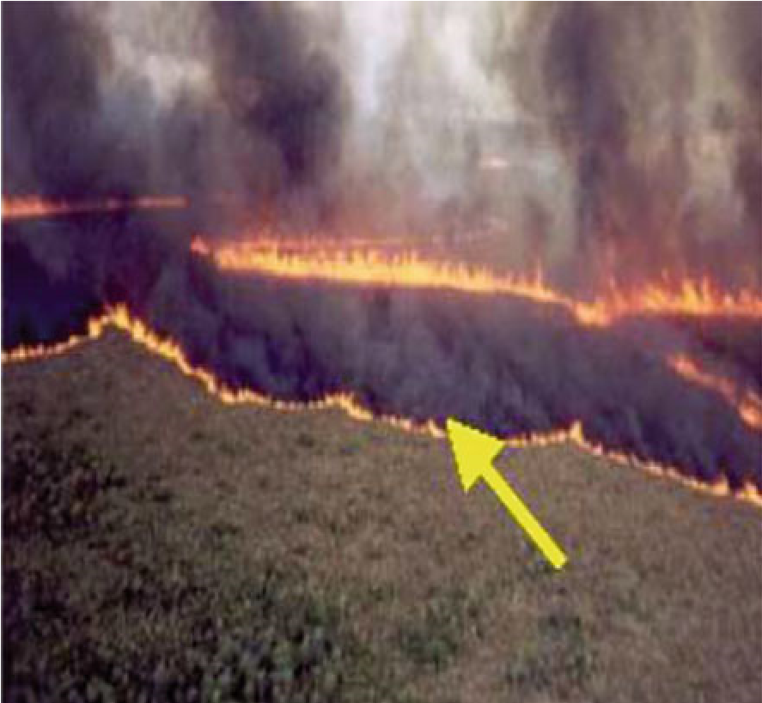

CROWN FIRE

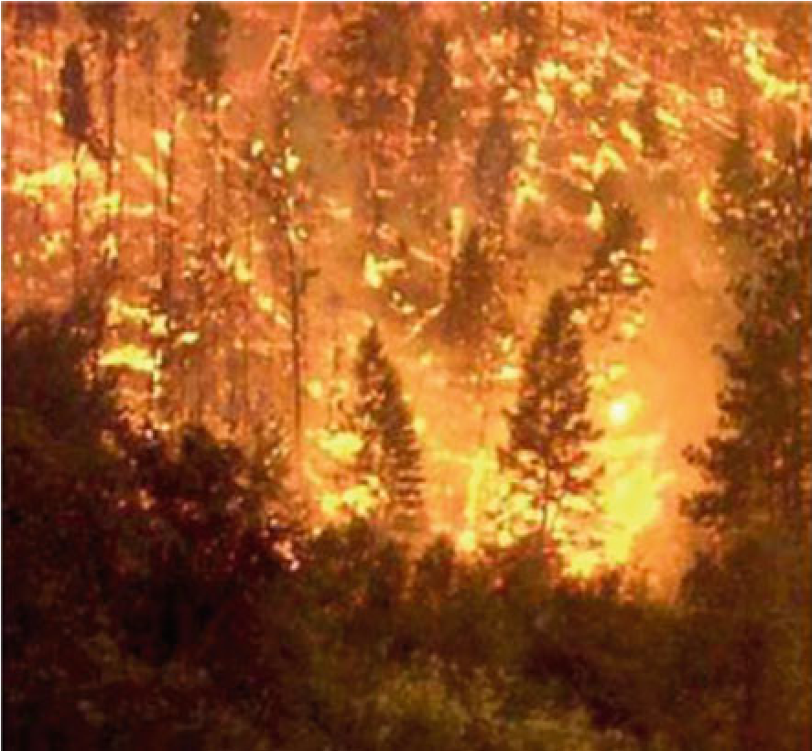

reptiles like tortoise. But problem with this type of reptiles is their slow nature because of which their tracking will be very difficult .

Surface fires occur on the ground and the spread of this type will always take a regular shape and will usually depend on the speed of wind. To detect this type of fire which will not only produce flames but will also generate smoke one can go for smoke sensor. One such use of smoke to detect fire in home environment is discussed in . In this article, authors have given importance to the optimization of power in terms of both the hardware and software. Lastly, the crown type of fires will burn the complete tree right from the root to the top most leaf through the stem. This type of fires will give much more flame then smoke. To detect these fires one needs a very robust sensor that can withstand a very high temperature.

# Forest Fire Detection Techniques

With reference to the work carried out, development shown in the field of fire detection and monitoring, the techniques used can be under categories which use

1. Techniques which use animals as sensors or animal behavior as sensors to detectfire.
2. Techniques which use Wireless Sensor Networks to detect fire.
3. Techniques which use image processing to detect and monitor fire.
4. Techniques which use cameras for visual interpretation to detect fire.
5. Techniques that use Unmanned Aerial Vehicles (UAVs) to detect fire.

**S**

**TECHNIQUE**

Techniques

which uses

animals as

sensors or

animal

behavior as

sensors to

detect fire

Techniqu

es

which us

es

Wireless

Sensor

Networks

dete

ct

to

fire

Techniques

which uses

Image

Processing

detect

to

fire

Techniques

uses

which

cameras

for

visual

interpretation

to detect fire

Techniques

uses

that

Unmanned

Aerial

Vehicles

(

UAVs) to

detect fire

**Background Study**

Forest fires break out in India from November-May every year due to various natural and anthropogenic reasons including accumulation of inflammable materials such as dry leaves, twigs, pine needles, etc.

This is 2.7 times more than the fires reported between November 2019 and June 2020. This includes large, continuous and repeated forest fires.

The country has seen this increase after a decrease in forest fire counts in the last two most recent forest seasons — November 2018-June 2019 and November 2019-June 2020.

[Odisha reported the maximum fires among all states](https://www.downtoearth.org.in/news/environment/odisha-recorded-the-most-forest-fires-in-india-last-season-78129)(51,968), followed by Madhya Pradesh (47,795) and Chhattisgarh (38,106).

[Uttarakhand recorded the sixth-highest fire](https://www.downtoearth.org.in/news/climate-change/climate-crisis-uttarakhand-may-see-forest-fires-round-the-year-74926) counts in the country; incidences were up 28.3 times this forest fire season compared to last.

**Project Objectives**

### [Fire detection systems](https://amzn.to/3235qA2) are designed to discover fires early in their development when time will still be available for the safe evacuation of occupants. Early detection also plays a significant role in protecting the safety of emergency response personnel. Property loss can be reduced and downtime for the operation minimized through early detection because control efforts are started while the fire is still small. Most alarm systems provide information to emergency responders on the location of the fire, speeding the process of fire control.

### Project Flow

* The user interacts with a web camera to read the video.
* Once the input image from the video frame is sent to the model, if the fire is detected it is showcased on the console, and alerting sound will be generated and an alert message will be sent to the Authorities.

**Feature.**

**Data Collection**

Artificial Intelligence is a data hunger technology, it depends heavily on data, without data, it is impossible for a machine to learn. It is the most crucial aspect that makes algorithm training possible. In Convolutional Neural Networks, as it deals with images, we need training and testing data set. It is the actual data set used to train the model for performing various actions.

**Image Preprocessing**

Image Pre-processing includes the following main tasks

* Import ImageDataGenerator Library.
* Configure ImageDataGenerator Class.
* Applying ImageDataGenerator functionality to the trainset and test set.

The ImageDataGenerator accepts the original data, randomly transforms it, and returns only the new, transformed data.

The dataset images are to be preprocessed before giving it to the model.

**Methodology**

The neural network model is to be built by adding different network layers like convolution, pooling, flattening, dropout and neural layers.

In this milestone, we start building our model by:

1.Initializing the mode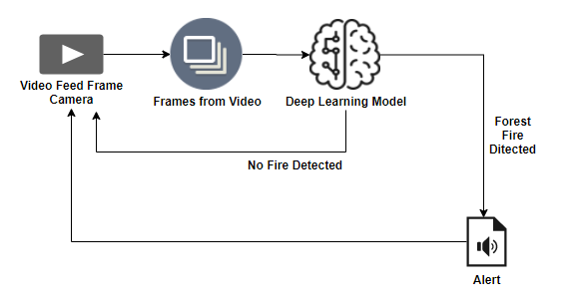

2.Adding Convolution layers

3. Adding Pooling layers

4.Flatten layer

5.Full connection layers which include hidden layers

At last, we compile the model with layers we added to complete the neural network structure.

.

###### **Fire Detection in the Forest Region**:

A classic UAV can autonomously fly over the forest area and detect the forest fire and yaw around the burning forest fire area. The UAV is well equipped with IR sensors, a 12K camera for image accretion, and the onboard CPU, which can broadcast the real-time video of the forest fire to the ground station using the signals that are used for remote navigation. The ground station would diagnose and take necessary measures to stop the forest fire. In parallel, the ground station can also control the UAV by sending the operational commands.

The onboard CPU has good computation power to perform the forest fire detection using YOLOv4 tiny, which has good detection speed with well-grounded accuracy . The YOLOv4 tiny model is divided into two layers, that is, the feature extraction layer and the processing layer. The feature extraction layer is the combination of the DarkNet and ResNet, similar to the feature-like pyramid network that has the convolutional layer, batch-normalization layer, and leaky ReLU layer. The problem of overfitting is shut out using batch normalization. The combination of the convolutional layer, batch-normalization layer, and leaky ReLU layer is called CBL. The combination of the convolutional layer, batch-normalization layer, and mish activation function is called CBM. The structure of CBL and CBM

###### **Prediction of the Possibility of Forest Fire:**

When UAV is patrolling over the forest region, it observes for the forest fire; if the fire is found, it drifts to that affected area and broadcasts all the data to the ground station and then helps the people extinguish the fire. If there is no fire in the forest, then UAV tries to find the possibilities of forest fire in that region. In general, forest fire is caused either by man-made errors or natural errors. The man-made errors that lead to forest fire are campfires that are not completely turned off, used and thrown mosquito coils, the smoked cigarettes remain, and tribal traditions related to fire. The natural causes that lead to forest fire are lightning , combustion of dry vegetation, and volcanic activities. UAV predicts the occurrence of forest fire based on any of the above-stated situations . UAV finds the possibilities of fire such as oxygen, fuel, and heat , while it is patrolling and transmits the results to the ground station.

##### **3D Modeling of Forest Fire** :

3D modeling of the forest-fire-affected area helps the ground station to diagnose and analyzes the situation for extinguishing the fire and helps know the direction of the forest fire; this information is very crucial and reduces the time of extinguishing. Existing techniques for forest fire modeling are empirical and enhancement of the modeling is needed [36]. The motivation for generating a 3D forest fire model is from photogrammetric research, which enables us to generate 3D models from images with high accuracy. In this work, much effort is spent on the creation of 3D images and LiDAR.

###### **Construction of 3D Forest Fire Modeling :**

The spatial resection technique of photogrammetry is used to estimate the position of the trees in the forest by measuring evenly distributed feature points across the 2D images of the forest. The recovery of positions of tress from various directions is called “relative orientation.” Many works have been done using pixel correspondence from scaled tree positions. Recent developments have been made to generate 3D models using the 2D images using LiDAR for outdoor 3D modeling. In this work, we have adopted some of the techniques from [33]. Unlike well-designed interior images, outdoor areas such as forest, farms, and parks contain many objects. Due to relative positioning constraints for data acquisition, sampling of the surfaces is difficult using the traditional methods. Orientation of the images and distance between the tress and other objects can be easily done using LiDAR. To deal with the inconsistency of the data bottom-up approach is used. LiDAR-generated 2D images are collected perpetually from the LASER while flying in forest areas at a high speed.

**Conslusion:**

Fire detection systems increase response times, as they are able to alert the correct people in order to extinguish the fire. This thus reduces the amount of damage to the property. Fire detection systems can be connected to sprinklers that will automatically respond when a fire is detected. A comprehensive survey covering the articles of last decade has been presented in this article. The potential benefits, feature of interest for forest fire detection monitoring and providing assistance to firefighting have been highlighted in the review of the literature. As forest fire is one of the most active disaster events in all most all the countries around the world, availability of information from multiple sources is always critical. The aim of this article was to provide a comprehensive view existing technologies with respect to different fields, viz., use of wireless sensor networks, use of image processing, use of cameras, use of animals as biological sensors, and use of UAVs to detect and monitor fire incidents. We as authors of this article hope to see a further improvement in the area of the literature review in the above-mentioned fields in the future.